COMPONENTS OF WINDOWS DESKTOP
The computer desktop window is the area you see on a monitor once a computer has loaded its operating system. The desktop is made up of three parts; the icons, the task bar and the background.
ICONS
An icon is a symbol on a computer that can be used to represent an object, file or even a program, such as folders, Microsoft Word, or My Computer.
TASKBAR
A rectangular bar located at the bottom of the desktop, displaying icons for applications that are open on a computer.
DESKTOP BACKGROUND
The area behind the icons on the computer monitor, visible after the computer completes booting. It can be hidden by an open applications or program.

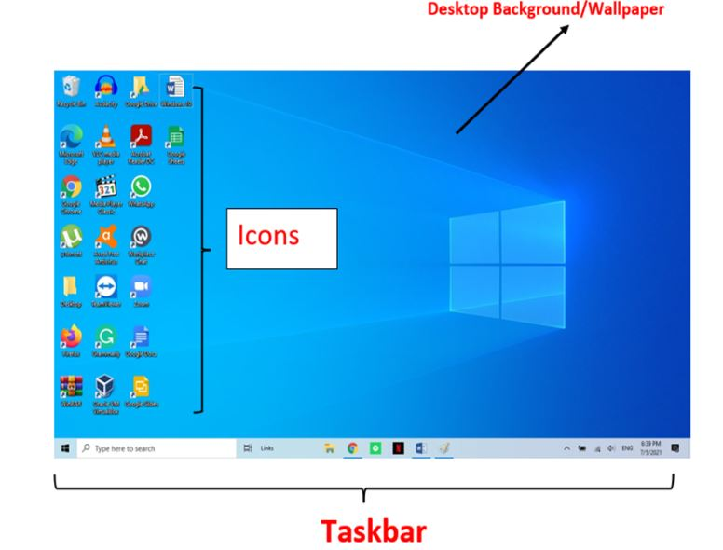

STEPS TO CREATE AND RENAME A FOLDER ON DESKTOP
How to create a folder on the Windows desktop:
- Right-click anywhere on the desktop to open the context menu.
- From the context menu, hover over "New" to reveal a submenu.
- Select "Folder" from the submenu.
- A new folder will be created on the desktop. Type the desired name for the folder.
- Once you have entered the folder name, press Enter on the keyboard.
How to rename a folder on the Windows desktop:
- Locate the folder you want to rename on the desktop.
- Single-click on the folder icon to select it.
- Once the folder is selected, wait for a moment, then click on the folder name again (or press F2 on the keyboard). This action will highlight the folder name.
- Type the new name for the folder.
- Press Enter on the keyboard to save the new name.

